Human Resource Management
Andrea Reed
Webster University

Annotated bibliography: Human Resource Management
Salman, I (2015). Employees' perceptions of human resource management practices and knowledge sharing behavior : a dissertation presented in partial fulfillment of the requirements for the degree of Doctor of Philosophy in human resource management (HRM) at Massey University, Palmerston North, New Zealand. Auckland: Massey University.
This Salman’s article heralds the idea that in this information age, knowledge is considered as the most important source of competitive advantage. As a result, all organizations should understand that the value of knowledge, especially that which resides in the human brain, also known as tacit knowledge is an intangible asset. The article, written based on empirical research, explains that an organization’s capability is proportional to the employee’s knowledge. As a result, some of the un-ignorable organizational goals which all human resources should have are to learn to improve employees and organization’s capabilities. Still, the research argues that there is need for future research, that would give a clear blue-print on how employee sharing activities, can be used to provide benefits to employees and organizations when it comes to quest for improving capabilities. This research article will be used to explain, the need for equipping employees with knowledge. Knowledge makes employees become capable for their task. The article also will provide why further research about Knowledge sharing is paramount, in organizations.
Gillani, S. M. F., Iqbal, S., Hassan, H. & Rasheed, M. (2017). HRM Practices and Knowledge Sharing: Employees’ Perception Study. Malaysia, University Utara Malaysia.
This article is an empirical research article, which also talks about the Human Resources practices as well as knowledge sharing, as an employee’s perception study. The study examines the human resource management effects in regards to reciprocity and practices of knowledge sharing behaviors. The article argues that in any given organization, the employees bear a big mandate for an organization’s effective performance. Sharing of knowledge according to this article, helps the communication of their knowledge with their co-workers and the management, making them perform their task in a better way. Thus, successful sharing of knowledge is advantages, both to the employees and the organization. This research also argues that despite several studies on this topic, there is little research, carried out on Human Resource Management (HRM) practices and knowledge sharing in developing organizations. Using banking sector in Pakistan as an example, this study will be used to explain that recruitment, reciprocity and selection as well as performance appraisals how big influence on knowledge sharing behaviors in organizations.
Igbal, S. (2016). “Employees’ perception regarding the role of specific HRM practices in knowledge intensive firms”. International journal of social sciences and management. Vol. 3, Issue-4: 246-255.
This paper on the other hand, investigates the employee’s perception on the association between Human Resource Management (HRM) practices and employees in regards to knowledge sharing. Out of research done on 390 employees, the confirmatory analysis explains that HRM practices, rewards an organization, by ensuring a positive relationship in terms of knowledge sharing. This also reflected a positive relationship, in terms of organizational and individuals capabilities in workplaces. This study thus perceives that human resources practices such as selection and recruitment have direct and greater impact on the knowledge sharing than gluing on the reward systems. This study then proves that an organization’s capability lies on the human resource powers, in things such as recruitment and selection. This study therefore, will be very helpful for the researchers, scholars, practitioners, employees and organizational leaders in terms of revealing the need for effective human resource management practices. Thus, it is agreeable to mention that the study makes a very valuable contribution, to good approachability practices which HRM should comply with. To that extend, it is an article that should be used to reference that which Human resource Managers should also put forward, in managing of their organizations.
Guest Contributor (2018, November 12). Top Benefits of Knowledge Sharing Across an Organization. Your training edge. Retrieved http://www.yourtrainingedge.com/top-benefits-of-knowledge-sharing-across-an-organization/
An article written by Guest contributor to online training edge explains that today, cultured companies have realized there is enormous significance to employee capability when individuals share knowledge in their organizations. According to this author, this issue is an essential constituent when it comes to the success of corporate. From customer services to sales and marketing, the issues about knowledge sharing can easily boost the functionality of a Company. Companies can easily refill gaps, ensure increment of innovation, output as well as stimulate leadership if knowledge sharing has been fostered as a culture in an organization. The article therefore supports the idea that knowledge sharing is very much important. Thus, those companies that would want to attain the best when it comes to meeting the organizational goals, should learn to embrace knowledge sharing among employees within their organizations. Arguably, this article therefore will be used to encourage HRM of the need to ensure knowledge is continuously shared among employees.
Brown, P. B. (2008, February 19). Getting the Most Out of the Human Asset. The New York Times. Retrieved https://www.nytimes.com/2008/02/19/business/19toolkit.html
This is an experience related article, written from personal point of view. It acknowledges the fact that any company’s most valuable asset is its people. As such, employees should be the main target before a company settles on whom to employee. For instance, organizations should prioritize employees who got the required information. This is important because it enables the employees to operate effectively over time. After this has been achieved, the Human Resource’ responsibility would be to create effective methods, that would help the employees to transfer information to others. The article further argues that while some things can be written doing, mentoring, arranging consultation meetings and phase retirements can be some of the important ways of evoking knowledge sharing in an organization. Notably, this article explains that knowledge management process is very much important, for the organizations that want to strive, in this business’ dynamic environment. Knowledge process according to this author involves, knowledge storage, organizing and sharing. This article therefore, is very important, in proving that successful knowledge management, which would usually result in best possible ways, to leverage and apply the captured, stored and organized knowledge, in an organization.
Lambooij, M., Sanders, K., Koster, F., & Zwiers, M. (2006). Human Resource Practices and Organizational Performance: Can the HRM-performance linkage be explained by the cooperative behaviors of employees? Management revue, 223-240.
Lambooij et al, (2006) addresses the question to whether the connection between Organizational performance and HRM can easily be explained by the cooperative behaviors of the employees and strategic internal fit of the HRM. This article also means that the more managers know about internal fit, which is HRM the manner in which how practices aligned by themselves, and how the HRM is aligned to the organization, also known as strategic fit, the better the employees carry out their duties. The article argues that this knowledge makes them behave cooperatively with their co-workers and their supervisors. This therefore, happens based on sharing information and human resources’ practices. This article helps envision the need for good strategy and internal environment, in an organization, as a way of enhancing communication in the institution.
Wang, S., & Noe, R. A. (2010). Knowledge sharing: A review and directions for future research. Human resource management review, 20(2), 115-131.
Wang and Noe on the other hand, explain that for the knowledge management to be a success, it all depends on the sharing of information in an organization. By reviewing quantitative and qualitative studies, with individual’s level knowledge sharing, this article proves that it is very important for the organization to understand how to share information. This article, is useful because it goes ahead to identify five areas, where managers should put emphasis when it comes to knowledge sharing. This includes cultural characteristics, team and interpersonal characteristics, organization contextual, motivational factors and individual characteristics. To that extend, this article also, explains in details specific areas where, an organization should ensure proper sharing of information.
Opportunities for Improvement
Fong, C., Tan, B., Lee, V. & Ooi, K.(2011). HRM Practices and Knowledge Sharing: An Empirical Study. International Journal of Manpower, 32(5/6):704-723. DOI: 10.1108/01437721111158288
This article investigates the relationship between human resource management (HRM) practices and knowledge sharing from the Malaysian business setting. The outcomes demonstrate that recruitment and selection collaboration, training and advancement, and performance study, demonstrated a positive relationship with knowledge sharing, as seen by the supervisors in the Malaysian assembling and service organizations.
The study structure in this investigation was cross-sectional as opposed to longitudinal. Henceforth, despite the fact that the SEM technique was embraced, the translations of the reason impact relationship among the factors couldn't be resolved. Discoveries from this investigation ought to be useful for HRM officer in developing nations, for example, Malaysia, who intend to create aggressive knowledge sharing capabilities through the selection of HRM practices.
The study contributes in the development of an estimation arrangement of HRM practices and knowledge sharing that could encourage future research on human resource the management, and additionally featuring essential ramifications for HR managers in developing nations.

Cabrera, E.F., and Cabrera, A. (2005), ‘Fostering Knowledge Sharing Through People Management Practices’, International Journal of Human Resource Management, 16, 720–735.
This article seeks to recognize those HRM practices that are best in urging employees to share knowledge. It is to the effect that the HRM literature offers two fundamental points of view that an organization can receive to oversee organizations with its workers. From one viewpoint, the exchange based point of view, which includes the use of HRM practices that cultivate singular transient trade connections among workers and the organization, speaks to the customary point of view. Then again, high-involvement HRM practices, which accentuate common long haul trade connections, speak to a more creative point of view.
Hayati, A., Toulson, P. &Tweed, M. (2014). Exploring Employee Perceptions of the Relationships Among Knowledge Sharing Capability, Organisational Culture and Knowledge Sharing Success: Their Implications for HRM Practice. Retrieved from: https://snellman-kesayliopisto.mobie.fi/wp-content/uploads/2014/10/Orgculture-sharing.pdf
This research integrates the four qualities with knowledge sharing capacity factors to additionally investigate their relationship with knowledge sharing achievement. In this investigation, they characterize knowledge sharing accomplishment as the degree to which beneficiaries get commitment for, to, and satisfaction with shared knowledge. In light of their past discoveries and the literature survey, their applied structure is adjusted and introduced another knowledge sharing system as shown in Figure 1.
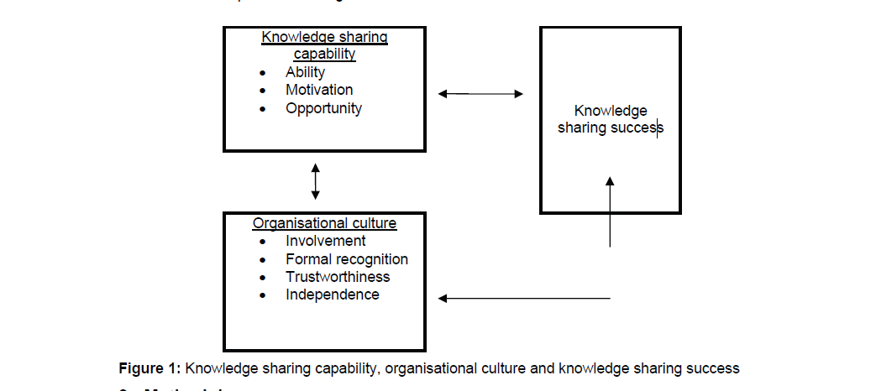

Recommendations for Improvement
Concerning sharing procedures, in the literature we discover thinks about indicating proof that the application, regardless of whether separately or mutually, of high-involvement HRM practices may urge workers to share what they know.
Chang, T.J., Yeh; S.P., and Yeh, I.J. (2007), ‘The Effects of Joint Rewards System in New Product Development’, International Journal of Manpower, 28, 276–297
This article demonstrates that a reward framework that qualities aggregate efforts and helpful practices among individuals from various utilitarian territories might be a viable instrument for cultivating knowledge creation and advancement. As per these creators, in light of the fact that the sharing of knowledge is an action that requires aggregate efforts, group based prizes is a particularly appropriate practice for empowering knowledge sharing and knowledge trade forms.
Cabrera, A., Collins, W.C., and Salgado, J.F. (2006), ‘Determinants of Individual Engagement in Knowledge Sharing’, International Journal of Human Resource Management, 17, 245–264
The article finds a positive connection between HRM practices orientated towards cooperation and recognizable proof with the organization, and the employees' eagerness to share knowledge. Collins and Smith (2006) additionally reason that high-inclusion HRM practices add to the formation of an organizational social atmosphere where workers will share their insight.
Every one of these contentions bolster the possibility that high-involvement HRM practices specifically energize knowledge sharing practices. In any case, a few creators recommend that these practices may not reinforce these practices specifically; along these lines, they might be inadequate for this reason in view of the inborn qualities of individual knowledge.
Cabrera, A., Collins, W.C., and Salgado, J.F. (2006), ‘Determinants of Individual Engagement in Knowledge Sharing’, International Journal of Human Resource Management, 17, 245–264.
Argues that it very well may be viewed as that high-inclusion HRM practices don't apply their impact straightforwardly on the degree to which knowledge is shared but instead that they add to the age of the dedication fundamental for workers to will share what they know. Through long haul interests in employees, high-involvement HRM practices flag to workers that they speak to a noteworthy wellspring of upper hand for the organization, driving thusly to a more prominent feeling of organizational connection and participation, that is, more prominent effective commitment. Similarly, high-involvement practices are probably going to be seen as a solid flag of the organization's help, trust, and commitment towards its employees. This cultivates the foundation of a commonly fortifying high-speculation employer– worker relationship that spurs employees to make more prominent commitments to the organizational objectives, by showing additional optional efforts, for example, hierarchical citizenship conduct and knowledge sharing.
Studies can be found in the literature that demonstrate observationally the job of commitment as a component through which factors identified with HRM impact hierarchical performance, in this manner giving proof of the interceding job of commitment.

Agarwala, T. (2003), ‘Innovative Human Resource Practices and Organizational Commitment: An Empirical Investigation’, International Journal of Human Resource Management, 14, 175–197
This is an study conducted in which commitment was shown as the relationship between HRM, from one perspective; and worker fulfilment, the aim to stay with the organization, and the organizational performance, on the other. It shows that the effect of HRM practices on hierarchical performance was more stamped when these practices created commitment. For example, in examining innovation intensive organizations, it presumes that emotional commitment assumes a basic job by mediating the relationship between mental contract satisfaction and knowledge sharing conduct, which thus firmly identifies with development performance.
Hislop, D. (2003), ‘Linking Human Resource Management and Knowledge Management via Commitment. A Review and Research Agenda’, Employee Relations, 25, 182–202.
Hislop summarizes the idea of high involvement by observing that, it very well may be recommended that high-involvement HRM practices impact workers' eagerness to share knowledge, to the degree that these practices are fit for developing effective commitment of the employees. In this manner, effective commitment develops as the focal variable that makes it conceivable to incorporate HRM.
Practices of HR in Organizations Using HR Concepts
Chang, T.J., Yeh; S.P., and Yeh, I.J. (2007), ‘The Effects of Joint Rewards System in New Product Development’, International Journal of Manpower, 28, 276–297
The authors here state that singular knowledge is a significant resource that may give status and power on the individual who has it; subsequently, sharing this knowledge is frequently seen by the person as lost impact inside the organization. The potential estimation of individual knowledge produces pressure among employees and the organization over who claims and who controls their insight. Therefore, any effort with respect to the service to oversee and control it, or to make individuals share it, is probably going to create an inward clash in the employee. In this manner, the inquiries that presently emerge are as per the following. By what method would organizations be able to determine this contention? What are the systems by which high-involvement HRM practices impact the degree to which knowledge is partaken in the organization?
A recent body of research recommends that individuals' propensity to share knowledge depends not just on the HRM practices concocted and connected by the service yet additionally on mental components, for example, emotional commitment. Hierarchical commitment is an idea gotten from social brain science and humanism, advancing for over five decades in the field of organizational conduct.
Meyer, J., and Allen, N. (1991), ‘A Three-Component Conceptualization of Organizational Commitment’, Human Resource Management Review, 61–89
Meyer and Allen argue that commitment is the reason that legitimizes the selection of a worker to stay faithful to the organization in which he/she works. These authors recognize three factors that clarify this conduct of staying in the organization, which offer ascent to the three types of commitment that include the tri-dimensional model: effective (wish), continuation (need) and normative (obligation) commitment. On account of the effective measurement, the factor that clarifies why the worker stays in the organization is the individual connection and recognizable proof with the organization’s objectives and qualities. In this way, workers with solid effective commitment remain faithful to their organization since they need to. In any case, workers with duration or regulating commitment stay with the organization since they have to or on the grounds that they believe they should, individually.
A broad literature bolsters a positive connection between effective commitment and additional job conduct; moreover, a few writers view this as the main type of commitment that drives a worker to show this sort of conduct. Along these lines, a few studies keep up that when the organization that joins people and gatherings with the organization is effective commitment, workers will play out an additional optional exertion that, by adjusting their interests to those of the organization, drives them to give larger amounts of hierarchical citizenship conduct and knowledge sharing.
Cabrera, E.F., and Cabrera, A. (2005), ‘Fostering Knowledge Sharing Through People Management Practices’, International Journal of Human Resource Management, 16, 720–735
Considers the store of hierarchical knowledge offers ascend to what is known as an open decent social predicament. This difficulty emerges when the joint commitments made by a few individuals from the network are accessible to every one of the individuals, paying little mind to singular commitments. The reward structure of an open decent empowers pioneering conduct, so that workers will tend not to add to the arrangement of the mutual knowledge and in the meantime will attempt to free-ride on the commitments of others. On the off chance that that procedure commands, general society great does not get accommodated.
Approach of HRM in Organizations on Selected HR Topic
Hayati, A., Toulson, P. &Tweed, M. (2014). Exploring Employee Perceptions of the Relationships Among Knowledge Sharing Capability, Organisational Culture and Knowledge Sharing Success: Their Implications for HRM Practice. Retrieved from: https://snellman-kesayliopisto.mobie.fi/wp-content/uploads/2014/10/Orgculture-sharing.pdf
This article contends that the significance of organizational culture and a mode of knowledge spread (through consolidating people's capacities, inspirations and chances to share knowledge) be given nearer consideration in developing HRM practices that mean to encourage knowledge sharing. They contend that while the significance of employees' abilities to effectively share knowledge has been underscored, their sharing practices can likewise be influenced by a hierarchical culture that fortifies such knowledge sharing.
Here, they define organizational culture as a mutual qualities set that guides employees to communicate and act expressly in the everyday work environment. Culture shapes individuals' suspicions about what knowledge is vital and recognizes which is hierarchical and which is person. In this manner, culture shapes the creation and appropriation of new knowledge. Organizations that esteem knowledge as being significance to their long haul performance ought to have a profound comprehension of the effect of culture towards knowledge sharing. Since people bring their own qualities, frames of mind and convictions to the working environment, their dimension of sharing capacities and also knowledge sharing achievement may vary. Accordingly, it is an essential test for organizations to build up a culture that may create and improve their employees' ability to share knowledge.
This article further proposes another conceivable methodology that methodically re-arrange/re-plan the methodology of potential knowledge driven HRM frameworks. Accentuation ought to be given to incorporating the nearby workforces' worthy social qualities into the HRM practices structure. Acknowledge that workers' relationship in organizational exercises, whereby their commitments are perceived inside a dependable situation, will increase hierarchical knowledge sharing achievement. For example, knowledge sharing practices have suggestions for promoting and prescient assessment criteria in enlistment and selection practices that are a piece of these HRM forms. Additionally, the ramifications of these discoveries can specifically be found in training and improvement. In building up the preparation program, the methodology ought to be more learner focused to permit more workers' support in advancing the cross-fertilization of thoughts among them. Urging them to participate in open exchange or discussion amid the training session will additionally build up their relational abilities and competency.
Salma, I. (2016). Employees’ Perception Regarding the Role of Specific HRM
Practices in Knowledge Intensive Firms. Int. J. Soc. Sc. Manage. Vol. 3, Issue-4: 246-255. DOI: 10.3126/ijssm.v3i4.15888
This Salma’s article states that knowledge sharing relies upon workers having knowledge (wellspring of knowledge) and employees getting that knowledge. Knowledge sharing is an activity to use and apply the knowledge for input and approval. The paper sees that in the present knowledge economy, most organizations are seeking to be imaginative to keep up upper hand. Technology based organizations seek to upgrade their knowledge capacity to enhance development by activating the knowledge so as to accomplish upper hand.
Organizations' knowledge capacities rely upon workers' knowledge sharing that can prompt enhanced inventiveness and development. It further proposes that exchange of knowledge through sharing exercises is the best devices for fruitful development in a few surely understood worldwide organizations.
Through the employee's focal point, for example in the media transmission segment, workers see that their insight has a benefit an incentive in developing advancements and their insight sharing identified with specialized abilities can help both themselves ( through their own knowledge) and their organizations ( through enhance knowledge capacity) to get by in this unique business condition. He proposes a knowledge sharing model as found in Figure 2.

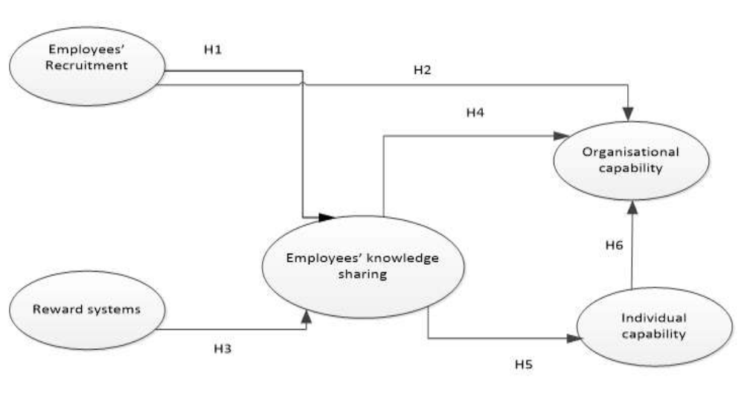
Figure 2: Proposed knowledge sharing model

Strengths and Weaknesses of the Current Approach
Most studies on the subject suggest that high-involvement practice is likely to foster knowledge sharing. In fact, a developing group of proof recommends that high-involvement practices are more emphatically identified with hierarchical performance than are exchange based practices. First, weakness of these studies is that they do not appreciate the fact that the correct individual practices that make a high-involvement point of view may contrast starting with one investigation then onto the next.
Also, numerous investigations for the most part incorporate a mix of the accompanying: formation of development open doors for employees through inside work markets; enlistment and selection dependent on the fit between outer hopefuls and the organization than on the explicit necessities of the activity; study and reward frameworks dependent on group or organization performance; remuneration practices intended to advance knowledge sharing among colleagues; training and improvement practices that underline employees' long haul development, group building and the advancement of firm-explicit knowledge, and so on as motivating forces to knowledge sharing. Such factors are not conclusive to meet the motivations of all employees because their motivations are likely not homogeneous.
Conclusion
Human capital ability to share knowledge has an imperative job in encouraging the development of knowledge to expand its esteem. Knowledge sharing is a movement or conduct including the exchange and spread of knowledge starting with one individual then onto the next. This is viewed as an essential procedure in light of the fact that, if effective, it results in shared scholarly capital. Analysts recommend that fruitful knowledge sharing will, to some degree, rely upon the limit of employees to compose their got knowledge resources through a system of relationships. This incorporates exercises like blending and using their recently gained knowledge and settling on selections on how they will communicate knowledge they consider as pertinent to other people.
Proper human resource management (HRM) practices can be an imperative medium that make an interpretation of knowledge sharing capacity into fruitful results. In any case, the absence of any accord, on which practices are "best" involves concern among organizations. It in this manner winds up imperative to indicate which practices are adding to the knowledge sharing upgrades that organizations need.
Another essential factor to consider in sharing knowledge by employees is inclusion. Organization portrays the capacity of organizations to enhance effective knowledge sharing by urging employees to effectively partake in hierarchical exercises, and to build up a feeling of "coordinated effort" among them through responsive service methodologies (identifies with community). Cook, J. and Wall, T. (1980) “New Work Attitude Measures of Trust, Organisational Commitment and Personalvneed Non-Fulfilment”, Journal of Occupational Psychology, Vol. 53, No. 1, pp 39-52.Trustworthiness is characterized as "confidence in the dependable aims of others and trust in the capacity of others" (identifies with relationship introduction and religious conviction). Formal acknowledgment clarifies the significance of all around created strategies as a method for accepting reasonable treatment from the managers and acknowledgment as steady employees for fruitful knowledge sharing (identifies with progressive system and relationship introduction). Freedom depicts employees' worries with receptiveness, rebelliousness and hazard taking (if selections fizzle) (identifies with progressive system and face).
Further, involvement can encourage the improvement of new work environment connections and help to limit people's disparities, prompting the advancement of trust all through the organization. Remunerating workers' participation and dynamic interest in the instructional meetings with credits or guides driving toward occupation advancement or redesigning through yearly performance study, shows an enhancement of people's skill level and connections training, ability and coordinated effort genuinely. Reward and evaluation frameworks have additionally been noted by different specialists in knowledge based organizations as huge indicators of workers' knowledge sharing practices. Moreover, supporting employees' adequate social qualities may enhance and keep up organizational degrees of consistency.

References
Andrawina, L. Govindaraju, R. Samadhi, T.A. and Sudirman, I. (2008) “Absorptive Capacity Moderates the Relationship Between Knowledge Sharing Capability and Innovation Capability”, Paper read at the 2008 IEEE International Conference On Industrial Engineering And Engineering Management, Singapore.
Brown, P. B. (2008, February 19). Getting the Most Out of the Human Asset. The New York Times. Retrieved https://www.nytimes.com/2008/02/19/business/19toolkit.html
Cabrera, A., Collins, W.C., and Salgado, J.F. (2006), ‘Determinants of Individual Engagement in Knowledge Sharing’, International Journal of Human Resource Management, 17, 245–264.
Cabrera, E.F., and Cabrera, A. (2005), ‘Fostering Knowledge Sharing Through People Management Practices’, International Journal of Human Resource Management, 16, 720–735.
Chang, T.J., Yeh; S.P., and Yeh, I.J. (2007), ‘The Effects of Joint Rewards System in New Product Development’, International Journal of Manpower, 28, 276–297
Cook, J. and Wall, T. (1980) “New Work Attitude Measures of Trust, Organisational Commitment and Personal need Non-Fulfilment”, Journal of Occupational Psychology, Vol. 53, No. 1, pp 39-52.
Fong, C., Tan, B., Lee, V. & Ooi, K.(2011). HRM Practices and Knowledge Sharing: An Empirical Study. International Journal of Manpower, 32(5/6):704-723. DOI: 10.1108/01437721111158288
Gillani, S. M. F., Iqbal, S., Hassan, H. & Rasheed, M. (2017). HRM Practices and Knowledge Sharing: Employees’ Perception Study. Malaysia, University Utara Malaysia.
Guest Contributor (2018, November 12). Top Benefits of Knowledge Sharing Across an Organization. Your training edge. Retrieved http://www.yourtrainingedge.com/top-benefits-of-knowledge-sharing-across-an-organization/
Hayati, A., Toulson, P. &Tweed, M. (2014). Exploring Employee Perceptions of the Relationships Among Knowledge Sharing Capability, Organisational Culture and Knowledge Sharing Success: Their Implications for HRM Practice. Retrieved from: https://snellman-kesayliopisto.mobie.fi/wp-content/uploads/2014/10/Orgculture-sharing.pdf
Hislop, D. (2003), ‘Linking Human Resource Management and Knowledge Management via Commitment. A Review and Research Agenda’, Employee Relations, 25, 182–202.
Igbal, S. (2016). “Employees’ perception regarding the role of specific HRM practices in knowledge intensive firms”. International journal of social sciences and management. Vol. 3, Issue-4: 246-255.
Lambooij, M., Sanders, K., Koster, F., & Zwiers, M. (2006). Human Resource Practices and Organizational Performance: Can the HRM-performance linkage be explained by the cooperative behaviors of employees? Management revue, 223-240.
Meyer, J., and Allen, N. (1991), ‘A Three-Component Conceptualization of Organizational Commitment’, Human Resource Management Review, 61–89.
Salma, I. (2016). Employees’ Perception Regarding the Role of Specific HRM Practices in Knowledge Intensive Firms. Int. J. Soc. Sc. Manage. Vol. 3, Issue-4: 246-255. DOI: 10.3126/ijssm.v3i4.15888
Salman, I (2015). Employees' perceptions of human resource management practices and knowledge sharing behavior : a dissertation presented in partial fulfillment of the requirements for the degree of Doctor of Philosophy in human resource management (HRM) at Massey University, Palmerston North, New Zealand. Auckland: Massey University.
Wang, S., & Noe, R. A. (2010). Knowledge sharing: A review and directions for future research. Human resource management review, 20(2), 115-131.

